% Roll No: 207

% Batch: C3

% Date: 04-05-2023

% Name: Mohanish Khambadkar

% Assignment 9

function [k] = secondOrder(x0,y0,h)

k1=h\*(-y0);

k2=h\*(-(y0+k1));

k=(k1+k2)/2;

end

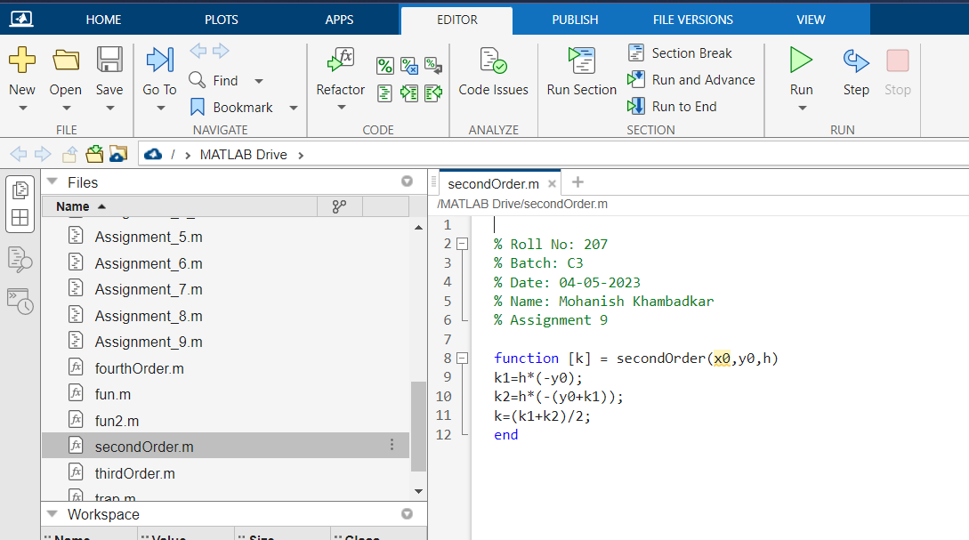

function [k] = thirdOrder(x0,y0,h)

k1=h\*(-y0);

k2=h\*(-(y0+k1));

k3=h\*(-(y0+k2));

k4=h\*(-(y0+(k1/2)));

k=(k1+4\*k4+k3)/6;

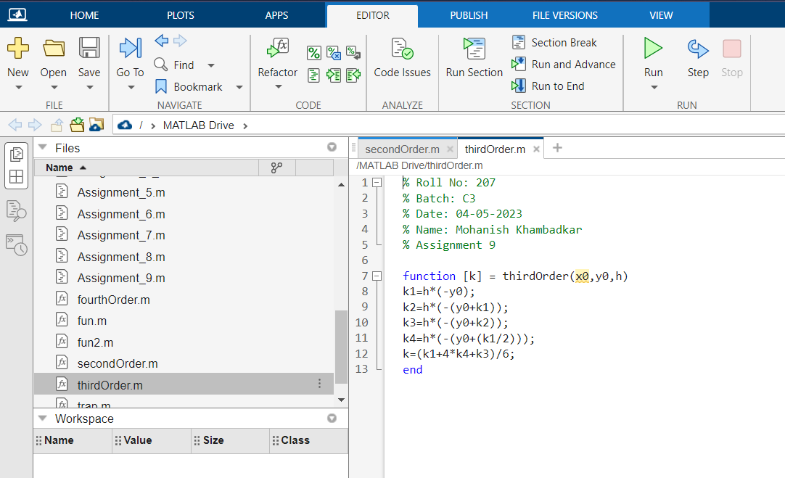end

function [k] = fourthOrder(x0,y0,h)

k1=h\*(-y0);

k2=h\*(-(y0+(k1/2)));

k3=h\*(-(y0+(k2/2)));

k4=h\*(-(y0+k3));

k=(k1+2\*k2+2\*k3+k4)/6;

end

